
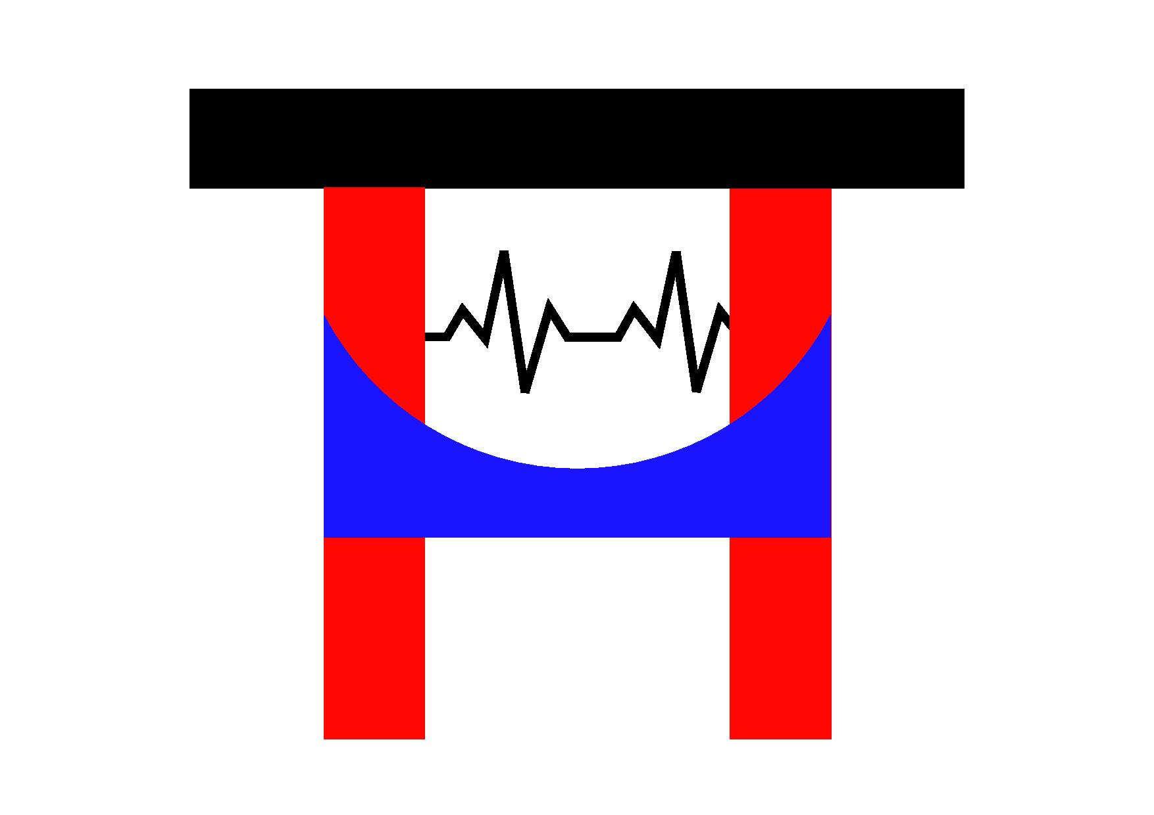
Trinidad and Tobago Healthcare United Kingdom Forum (TTHUF)
Registered Charity Number 1183695

TTHUF GIFT AID DECLARATION FORM
Boost your donation/subscription by 25p of Gift Aid for every £1 you give.
If you’re a UK taxpayer, using Gift Aid means that for every £1 you give, Trinidad and Tobago Healthcare UK Forum (TTHUF) can claim another 25p from HM Revenue and Customs. Gift Aid is reclaimed by TTHUF from the tax you pay for the current tax year. Your address is needed to identify you as a current UK taxpayer.

Just fill in this form and return to: Trinidad and Tobago Healthcare UK Forum, 74 Haynt Walk, London SW20 9NX. You can also scan and email the completed form to: tthuf@gmx.co.uk

Gift Aid declaration

Tick all that apply.

I am donating/subscribing £________ to TTHUF and would like to Gift Aid this donation.

I want to Gift Aid all future donations/subscriptions I make to TTHUF until further notice.
I want to Gift Aid all donations/subscriptions I have made to TTHUF in the past four years.

I am a UK taxpayer and understand that if I pay less Income Tax and/or Capital Gains Tax in the current tax year than the amount of Gift Aid claimed on all my donations it is my responsibility to pay any difference.

My details are:

First name _______________________________ Surname _______________________________

Home address _______________________________________________________________________
_________________________________________________________ Home postcode ____________
Signature ________________________________________________ Date ______/______/______

Please let us know straight away if you:
- want to cancel this declaration
- change your name or home address
- no longer pay enough tax on your income and/or capital gains to cover the tax we reclaim.

Higher rate tax payers
If you pay Income Tax at the higher rate or additional rate you can claim additional tax relief by including all your Gift Aid donations on your Self-Assessment tax return or ask HM Revenue and Customs to adjust your tax code.

